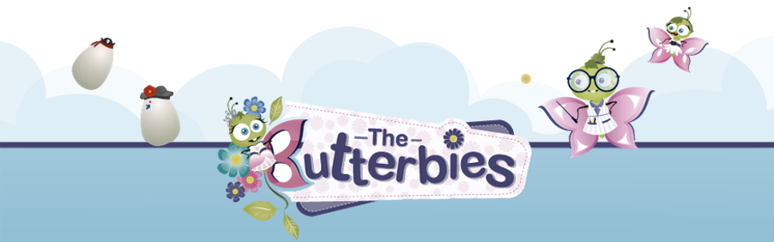
New and unique “The Butteries” app, where children learn valuable life skills by caring for a virtual pet, now available on the App stores.
APP WILL BE RELEASED THURSDAY 23RD OCTOBER 2014
Derry, Northern Ireland: 23rd October 2014 - Derry based children’s media company Parakite is proud to announce its beautiful virtual pet app, The Butterbies, is available today on Google Play and the Apple App Store and is free to download. This unique and completely new app offers a magical world for children to explore and love with a diverse range of interesting characters, settings and back stories.
The Butterbies received funding from Northern Ireland Screen, InvestNI and the European Regional Development Fund.
BACKSTORY
A butterfly egg is being delivered to the Butterfly village by a stork. The stork is blown off course and the egg falls on the roof of a nearby house. The egg rolls off the roof and lands on the windowsill of the child's bedroom. When the child awakes it sees the egg and starts to look after it and their adventures begin.
FUN FEATURES
The Butterbies is a Butterfly virtual pet adventure with games, dressing up, a Fairy and a Princess where the child needs to care for a lost caterpillar egg until it grows into a beautiful butterfly through a range of fun tasks and activities. The child takes care of the lost caterpillar egg by cleaning, feeding and playing with it while it grows into a beautiful butterfly and find its way back home to the Butterfly Village. Features include;
- 20+ unique butterflies to collect each with a different career and personality
- GROW your own virtual pet from an egg to a caterpillar until it becomes a butterfly
- COLLECT the Princess, Fairy, Witch, Ballerina, Mermaid, Pop star, Vampire and Astronaut butterflies
- FEED, clean and play with your virtual pet as it evolves
- ACHIEVEMENTS to unlock and get rewards as you level up
- DECORATE the pet's environment e.g. wallpapers, blinds, lamps and plants
- PLAY Dress up, Egg runner and many more..
- SHARE with friends e.g. photo creation/sharing
- TALK to your pet and listen back
- ADOPT new eggs from the nursery, who knows they may grow into a Fairy, Mermaid or Princess!
“This is our first app and we are really excited about it”, says Niall McShane and Raquel Pérez Sáenz, Creative directors at Parakite. “We have created a new and unique world for children to explore and interact with. The app has educational value in that it teaches children how to look after a virtual pet in a caring and responsible manner. Children of different ages will be able to enjoy the app at different levels and share the experience with adults”.
The Butterbies App is available for free from the Google Play https://play.google.com/store/apps and from the Apple App store at www.appstore.com or from the direct links below.
Apple Store: https://itunes.apple.com/us/app/butterbies-virtual-pet-game/id925276030?ls=1&mt=8
Google play: https://play.google.com/store/apps/details?id=com.parakite.butterbies
The app is illustrated by Raquel Pérez Sáenz and Niall McShane.
This app is recommended for children ages 4-8.
MEDIA KIT
Visit the Media Kit page on Butterbies.com for videos, screenshots and additional resources. Please click here.
http://www.butterbies.com/general-pages/media-kit-the-butterbies.html
THE BUTTERBIES WEBLINKS
Facebook: https://www.facebook.com/Butterbies
Twitter: https://twitter.com/Parakiite
YouTube: http://bit.ly/11S3g5X
Instagram: http://instagram.com/butterbies
Google+ Page: http://www.google.com/+Butterbiesapp

ABOUT PARAKITE LTD
Parakite LTD is an independent children's media publisher based in Derry, Northern Ireland founded in 2013. Parakite create magical new worlds for children to explore and love, with interesting characters, stories and adventures in strange and wonderful places.
Become a fan on Facebook: https://www.facebook.com/ParakiteInteractive
Follow Parakite on Twitter: https://twitter.com/Parakiite

MEDIA CONTACTS

In the UK: Amelle Aiche
Telephone number: + 44 (0) 7792732705
Email: press@parakiteinteractive.com
Web: http://parakiteinteractive.com/

